**Freedom GDD**

Studio Project 4

Done by group 15: Winston Chiu, Luke Tan, Ang Jun Ying, Ethan Heng

Supervisor: Victor Wee

**Overview** **2**

Concepts 2

Unique Selling Points 2

Minimum Platform Requirements 2

Competing Titles 2

Synopsis 3

Game Objectives 3

Game Rules 3

**Game Structure** **3**

Gameplay Controls 4

**Player** **5**

Player Character 5

Player Metrics 5

Player Weapons 5

**Character Line-Up** **7**

NPC Enemies 7

Enemy States 8

Enemy Spawning 8

**Art** **8**

Setting 8

Level Design 9

Audio 10

**GUI** **10**

Menu 10

**Reference Sources** **11**

# Overview

Title: Free The Gladiator’s Pits

Platform: PC standalone

Engine: Unity3D

Genre: 3D Wave Survival

Rating: R18, murder, violence, gore and blood  
Target: Casual gamer

Fight in the arena for freedom. The gladiator is a fighter that earns his freedom by killing others, hoping to be released from slavery in a bloody sport. Player moves around a small ring, fighting against other gladiators and beasts. Should the player take damage, the player will get debuffs and “scars”, where future rounds get harder due to physical injuries. Player can pick up weapons from dead enemies, and strives to survive in the gruesome environment known as “The Pit”.

## Concepts

First person

Mostly melee combat

Gladiator

Round based survival

## Unique Selling Points

1. Stunning particle effects
2. Blood bath

## Minimum Platform Requirements

OS: Windows XP SP2+,

Graphics card: OpenGL 3.0 onwards (Shader Model 2 .0) capabilities.

## Competing Titles

Clone Drone in the Danger Zone

Released in July 2021

Action, Indie

Space Gladiators

Released in March 2021

Action, Roguelite

COD franchise: Zombies mod

Action, FPS

## Synopsis

You play as a gladiator who is trying to climb the ranks of the gladiator games, killing all enemies and surviving as long as you can.

## Game Objectives

The objective of the game is to survive as long as possible, while killing all enemies.

## Game Rules

The Pits, is an enclosed fighting arena with small structures and walls. The Player enters the Pits and cannot leave until they kill the boss. Enemies will drop their weapon upon death while new enemies will enter the pit. As more enemies appear, the player has to think on his feet to find the optimal way to survive. Killing the boss will earn you a small respite and allow you to reenter the Hub to rest. Repeat until your last breath.

# Game Structure

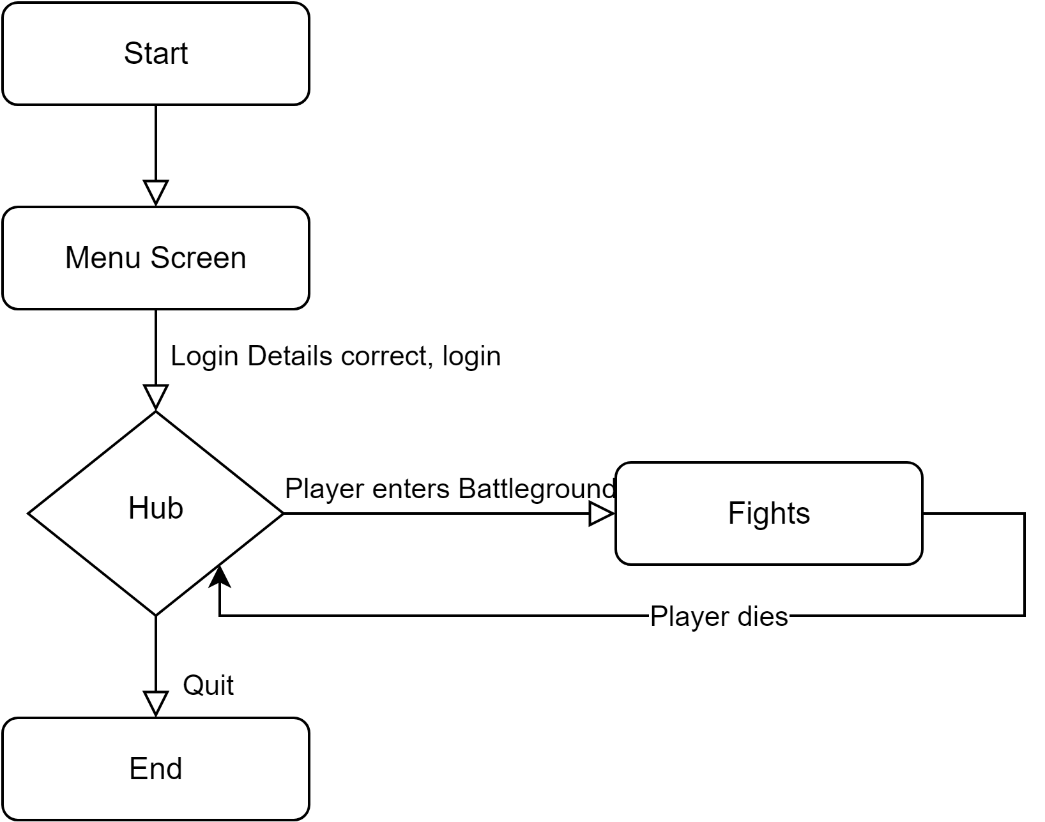

## Gameplay Controls

WASD for basic character movement

Spacebar to Jump

LShift: Dodge

Mouse Control for Front facing Direction

LMB: primary attack

Conditional:

1. Melee attack, ie swing sword
2. Bow, charge, release to shoot

RMB: secondary attack

Conditional:

1. Shield, defend
   1. If defend and LMB, shield bash
2. Spear charge
3. Hold to show melee throw arc

“E”: picks up item

# Player

## Player Character

## Player Metrics

Size: 2x5x2

Health: 100

Stamina: 100

Speed: 5

Jump Force: 5

Dodge Force: 100

Attack Speed: based on weapon

Attack Damage: based on weapon

Health system

1. 100 hp
2. Player takes damage from enemy attacks, projectiles, traps and environmental hazards
3. No natural healing
4. Consumables heal small amount (dropped occasionally by enemies)

Stamina system:

1. 100 units
2. Primary and secondary attack uses stamina
3. Dodging uses stamina
4. If stamina reaches 0, cannot have actions done, walking speed lowered
5. Regenerates over time
6. Shield block reduces stamina based on damage negate
7. If drops to 0, takes longer to recover from fatigue
8. Movement is slower under 25%
9. There is a pseudo cooldown of Xs ,after last action, before regeneration starts

## Player Weapons

Spawns with shortsword

Can pick up weapons from defeated enemies

Types of weapon:

UNARMED (barehanded)

1. Low damage
2. Low range
3. Fast attack speed

1 handed weapon:

1. Shortsword
   1. Medium damage
   2. Medium range
   3. Medium attack speed
   4. No special abilities
2. Shield
   1. Low damage
   2. Medium range
   3. Protect user
   4. Shield bash
3. Mace
   1. Medium damage
   2. Medium range
   3. Medium attack speed
   4. Stunning
4. Tomahawk
   1. Low damage
   2. Low range
   3. Fast attack speed
   4. No special abilities

2 handed weapon

1. Bow
   1. Medium damage
   2. Long range
   3. Charge time = strength and range
   4. Projectile system
   5. Consumes 1 arrow on attack, requires at least 1 arrow to fire
2. Spear
   1. Spear dash
   2. Long range
   3. Low damage
   4. Fast attack speed
3. Great Sword
   1. High damage
   2. Long range
   3. Low attack speed
   4. No special abilities

Other notable items

1. Arrows
   1. Required for bow to function
   2. Picking up a bundle gives 3 arrows
   3. Has a relatively straight path
   4. Is a projectile
   5. Is affected by gravity
2. Apples
   1. Only form of healing
   2. Upon picking up, heals the player by a small amount

Current Simplified Hands system  
All weapons currently that are 1 handed or 2 handed, when the player picks up a new weapon, will swap with their current item (Destroys their current weapon for the new one)  
Shield will be wielded 2 handed by the player

(If there is time) More advanced hands system

Player can pick up weapons when there is a free spot

Weapons are all right handed

If player picks up a 2 handed weapon, they drop all 1 handed weapons

If player picks up a 1 handed weapon, check if it is a defense or offense, defense is always offhand, offense is main hand

Weapons always replace current equipped

If player has a 2 handed weapon, and picks up a 1 handed weapon, they replace the item

# Character Line-Up

## NPC Enemies

| Name | Swordsmen | Shield Bearer | Archer | Spearmen |
| --- | --- | --- | --- | --- |
| Speed | 5 | 5 | 5 | 5 |
| Max Health | 100 | 100 | 100 | 100 |
| Weapon | Sword | Shield | Bow | Spear |
| Attack Damage | Based on weapon | Based on weapon | Based on weapon | Based on weapon |
| Attack Speed | Based on weapon | Based on weapon | Based on weapon | Based on weapon |
| Drops | Sword  Apple | Shield  Apple | Bow  Arrows  Apple | Spear  Apple |

## Enemy States

All melee enemies share the same behavior and states

Idle: defensive, the enemy looks around to find the player

Move: neutral, the enemy moves towards a point of interest either to attack or defend

Attack: offensive, the enemy attacks with their weapon from their spot

Death: the enemy dies and stops updating

Ranged enemies have an additional state

Vantage: The NPC will attempt to hide behind a cover or find a taller vantage point to attack the player.

## Enemy Spawning

Enemies will hop in from the walls continuously throughout a round. Has special spawn locations for each class, i.e. archers atop a tower, shieldbearers in a group.

Boss will spawn at the end of every round.

# Art

## Setting

The game takes place within a medieval roman colosseum as well as an underground dungeon.

Image of the Pits

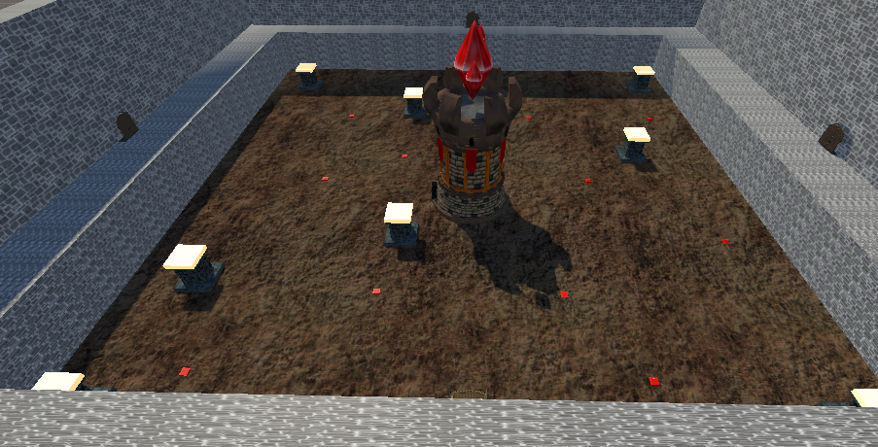

Image of the Hub  
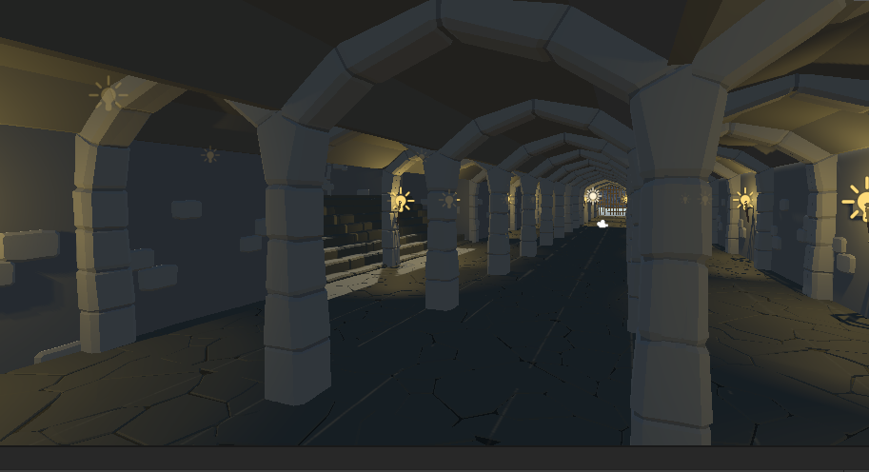

## Level Design

Square of size 100mx100m

Some structures within, ie huts, towers and walls

## Audio

| Name | Category | Description |
| --- | --- | --- |
| BG_Hub | Background music | Plays while player is in the hub |
| BG_Battle | Background music | Plays during battle |
| Others |  |  |

# GUI

HP bar

Stamina bar

Inventory Arrow count

Cross hair(if needed)

Example GUI:

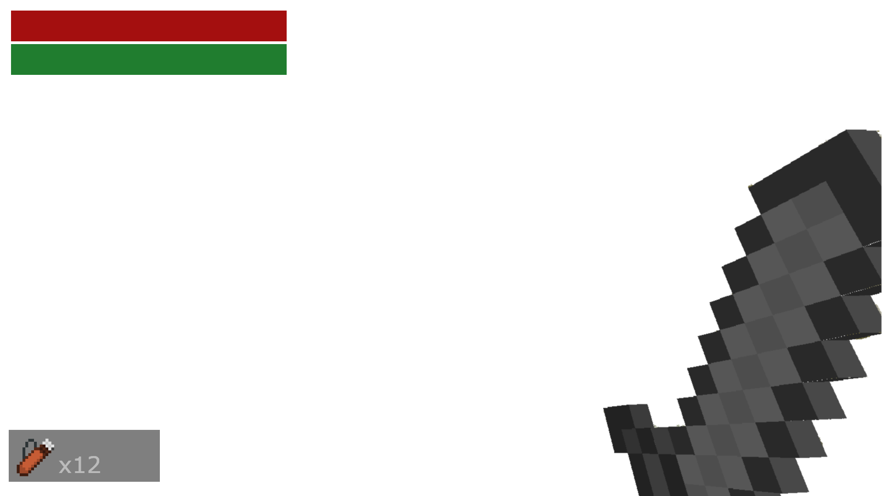

## Menu

Highscore = personal highscore

Settings page = if have time do visual effects and sound system, setting to control intensity

Play button = enter hub

Login button = if have time, set up database (local leaderboard)

# Reference Sources

<https://assetstore.unity.com/packages/3d/characters/modular-first-person-controller-189884>

<https://assetstore.unity.com/packages/3d/environments/landscapes/rpg-poly-pack-lite-148410>

<https://assetstore.unity.com/packages/3d/environments/dungeons/ultimate-low-poly-dungeon-143535>

<https://assetstore.unity.com/packages/3d/props/weapons/free-stylised-fantasy-weapons-77078#content>

<https://assetstore.unity.com/packages/3d/characters/humanoids/humans/lowpoly-medieval-peasants-free-pack-122225>

<https://assetstore.unity.com/packages/3d/action-rpg-melee-spear-38215>

<https://assetstore.unity.com/packages/3d/props/weapons/low-poly-rpg-fantasy-weapons-lite-226554>

<https://assetstore.unity.com/packages/3d/characters/humanoids/humans/spartan-warrior-143676>